TRANSPORT AND TELECOMMUNICATION INSTITUTE 
ENGINEERING FACULTY

Web Application Construction. Course Work
Web-based e-commerce online store of outdoor gear - SteelPoint

Student: Valentins Ozerovs
Group: 4301BDA
St. code: st85309
Lecturer: Arturs Greķe

RIGA, 2025
CONTENTS
INTRODUCTION 3
PROBLEM STATEMENT 4
FUNCTIONAL AND NON-FUNCTIONAL REQUIREMENTS 5
ARCHITECTURE AND TECHNOLOGIES 6
USER SESSION MANAGEMENT 7
EXTERNAL API INTEGRATION 8
CLASS STRUCTURE AND OOP PRINCIPLES 9
INTERFACE AND FEATURES DESCRIPTION 10
ALGORITHMS AND LOGIC 11
SEO OPTIMIZATION 12
WEB SECURITY CONSIDERATIONS 13
TESTING 14
DEPLOYMENT AND SETUP INSTRUCTIONS 15
CONCLUSION 16
APPENDIX 17

INTRODUCTION
SteelPoint is a prototype e-commerce web application designed for selling outdoor tools and tactical gear such as knives, multitools, machetes, axes, and shovels. The project uses modern technologies and clean architecture. Approximately 50 real-world products are showcased within categorized collections. The project’s name reflects the attributes of its products: strength, precision, and reliability.
The frontend is implemented in Vue 3 using Vue CLI and Vue Router, styled with SCSS and organized according to BEM principles. The backend uses Java 17 with Spring Boot and an H2 in-memory database. Data is loaded automatically during application startup. RESTful APIs allow the frontend to fetch and display dynamic data.
Key features include a paginated product catalog (see Figure A.1), a favorites system (Figure A.4), client-side filtering and sorting (Figure A.2), and a shopping cart drawer (Figure A.3). Product detail pages are partially implemented and currently show placeholder skeletons (Figure A.5).

PROBLEM STATEMENT
The objective is to develop a minimal but functional online store reflecting real commercial platforms. The user should be able to browse products, filter and sort them by category, add items to a shopping cart, and mark favorites.
The primary challenge was the integration of dynamic filtering and sorting logic through query parameters in the backend. The filtering logic is implemented in the filterProducts(...) method within the ProductController class (see Listing D.2), which delegates processing to a service class. Initial data is generated at runtime through the DataLoader class, where product objects are created and saved (see Listing D.1).
In addition to core functionality, the project emphasizes modern web development aspects such as responsive interface design, SEO considerations, accessibility, and a scalable architecture ready for session management, external API integration, and security enhancements. These aspects are addressed throughout the report.

FUNCTIONAL AND NON-FUNCTIONAL REQUIREMENTS
The system should allow users to:
- Browse products by category and paginate results.
- Filter and sort items by name, type, or price.
- View product detail pages with images and descriptions.
- Add products to a shopping cart and manage item quantities.
- Mark products as favorites and view them in a separate list.
- Interact with a responsive interface across multiple device types.
Future extensions include:
- User authentication and personalized profiles.
- Checkout workflow and online payment processing.
- Integration with external APIs (e.g., currency conversion, shipment cost estimation).
- Server-side filtering and advanced search.
Non-Functional Requirements
- Data should be loaded efficiently through RESTful APIs and dynamic UI updates must not require full page reloads.
- The application should be designed with protection against XSS, CSRF, and unauthorized access, supported by planned authentication and secure data handling.
- The interface must be intuitive and require minimal effort for common actions.
- UI elements must be readable, navigable with keyboard input, and include alternative text for visual content, aligning with WCAG guidelines.
- The system architecture should support migration to a persistent external database and modular integration of additional business logic and APIs.
- Semantic markup and meta configuration should improve search indexing, while SSR or pre-rendering may be adopted in future releases.

ARCHITECTURE AND TECHNOLOGIES
SteelPoint follows a modern layered client-server architecture. The frontend is a single-page Vue application with modular components: ProductCard, ProductList, TheHeader, and TheDrawer. Routing is handled using Vue Router (see Listing E.1), and component-level state is managed via the Composition API. SCSS files use BEM for consistent naming. The frontend file layout is visualized in Figure 4.
The backend is built using Spring Boot, with clearly separated layers: entities (Product, Category), DTOs (ProductDTO, see Listing D.3), service interfaces and implementations (Listings D.6–D.7), repositories (Listing D.5), and controllers (Listing D.2). All entities inherit from a common abstract base (BaseEntity → AbstractProductBase → Product) and apply JPA annotations. The application exposes a REST API (e.g., /api/products, /api/products/filter) used by the frontend.
A general architecture diagram is presented in Diagram A.8.

USER SESSION MANAGEMENT
User session management is essential for secure web platforms. Although user profiles and authentication are not yet implemented in the prototype, the system architecture is designed to support them without major restructuring.
Session handling can be performed using:
- JWT tokens for stateless authentication, supporting scalability and modern SPA architectures.
- HTTP-only cookies to protect sensitive data from client-side JavaScript access.
- Spring Security to provide standardized mechanisms for authentication, authorization, password handling, and CSRF protection.
The planned implementation enables persistent shopping carts, personalized product recommendations, protected checkout access, and role-based administration. This aligns with industry practices for scalable e-commerce systems.

EXTERNAL API INTEGRATION
To support functionality typically required in modern commercial platforms, the application architecture has been prepared for integration with external APIs. Planned use cases include:
- Currency Conversion API (e.g., exchangerate.host) to display product prices in multiple currencies and improve user experience for international shoppers.
- Shipment Cost Estimation API (e.g., DHL or ShipEngine sandbox) to calculate shipping fees based on destination and product weight.
- Payment Processing API (e.g., Stripe, PayPal) to securely handle checkout transactions in future releases.
Integrations would use backend service clients to secure credentials. This approach follows best practices in backend-mediated API communication for web applications.

CLASS STRUCTURE AND OOP PRINCIPLES
The backend demonstrates strong application of OOP principles. All entities extend a common abstract class BaseEntity, which contains shared fields like id and createdAt (see Listing D.4). A second abstract class, AbstractProductBase, defines common product-related properties like name, image, and description (see Listing D.4). The concrete class Product inherits from this and implements two interfaces—Priced and Describable (see Listing D.4).
Encapsulation is achieved using private fields with Lombok-generated getters/setters. Abstraction is used to isolate reusable logic. Inheritance ensures code reuse and consistency across models. Interfaces demonstrate polymorphism by defining behavior contracts.
These relationships are illustrated in UML Diagram C.1, which also shows the one-to-many association between Category and Product.

INTERFACE AND FEATURES DESCRIPTION
The interface includes a header, catalog, drawers, and pages for favorites and product details. Product cards display descriptive text, pricing, and optimized imagery. A drawer-based shopping cart interface allows users to manage item quantities without leaving the current page.
The application uses SCSS modules structured according to the BEM methodology, which ensures maintainable UI components. Responsive behavior is achieved through:
- media queries targeting tablet and mobile breakpoints,
- a flexible grid layout that adapts the number of columns,
- scalable fonts and spacing for improved readability.
Accessibility features include alt-text for images, keyboard-navigable controls, and high-contrast UI elements. These considerations align the interface with widely recognized usability and accessibility standards.

ALGORITHMS AND LOGIC
The logic behind cart and favorite functionality is implemented in composable stores (useCartStore, useFavoriteStore) using Vue’s reactivity.
- addToCart(product) checks if the product exists in the cart. If so, its quantity is incremented; otherwise, it is added with quantity one (Diagram B.1).
- toggleFavorite(product) checks if the product is already in the favorites list and either removes or adds it (Diagram B.2).
- applyFilters() processes both category and sorting filters (Diagram B.3).
On the backend, filterProducts() enables optional server-side filtering and sorting via query parameters. It is implemented using Spring Data JPA Specification and Sort objects (Diagram B.4, Listings D.2, D.6–D.7). Currently, only the client-side logic is used, but the backend is ready for extension in the future.

SEO OPTIMIZATION
Search Engine Optimization (SEO) has been considered to improve content discoverability and ranking. The current prototype applies:
- Semantic HTML structure (<header>, <nav>, <main>, <footer>, <article>)
- Meta Tags for titles, descriptions, and previews (Open Graph metadata)
- Sitemap and robots configuration to guide search crawlers
Future improvements include:
- Pre-rendering or Server-Side Rendering (SSR) for better SEO compatibility with SPA frameworks
- Structured Data Markup (Schema.org) to improve search visibility for products
These measures align the system with modern commercial SEO strategies.

WEB SECURITY CONSIDERATIONS
Security is a critical aspect of any e-commerce system. The current prototype is limited in this area, but several practices are planned for integration:
- Spring Security for authentication and authorization.
- Input validation on both frontend and backend to prevent injection attacks.
- Cross-Site Scripting (XSS) prevention by sanitizing user input.
- Cross-Site Request Forgery (CSRF) protection via Spring Security tokens.
- HTTPS/TLS to secure data transmission.
These measures will ensure that the system meets common security standards for web applications.

TESTING
The testing strategy combined functional verification with usability and basic accessibility assessment. Manual testing was performed across major application workflows:
- product browsing, filtering, and sorting,
- adding and updating cart items,
- saving and removing favorites,
- navigation across major routes without page reloads.
Usability testing evaluated how efficiently a user could locate and purchase an item. Observations indicated that page layout, actions, and filtering controls enabled intuitive navigation with minimal effort.
Accessibility testing included verification of:
- keyboard navigation,
- sufficient contrast ratios,
- presence of alt-text on product images.
Future testing improvements may include automated lighthouse audits, unit tests for REST endpoints, and end-to-end UI testing using tools such as Cypress or Playwright.

DEPLOYMENT AND SETUP INSTRUCTIONS
The application includes a Spring Boot backend and a Vue 3 frontend. Deployment steps are available in the GitHub repository (https://github.com/ozerovvalya/SteelPoint-Web).

CONCLUSION
SteelPoint demonstrates the design of a responsive e-commerce prototype. The application integrates dynamic filtering, sorting, favorites, and cart management, backed by a scalable API-driven architecture.
Beyond implemented functionality, the project establishes a solid foundation for modern web practices, including:
- full session management and user authentication,
- integration with external APIs for payment and shipping,
- enhanced accessibility and responsive adaptation,
- SEO optimization and structured metadata,
- security measures such as input validation and HTTPS enforcement.
With these improvements, SteelPoint can evolve into a secure, user-friendly commercial platform aligned with industry standards.

Link to GitHub public repository with all the source files of the Course Work - https://github.com/ozerovvalya/SteelPoint-Web

APPENDIX

A – User Interface Screenshots
- Figure A.1 — Main Product Catalogue with Pagination and Product Cards
(Referenced in Introduction and Interface Description) 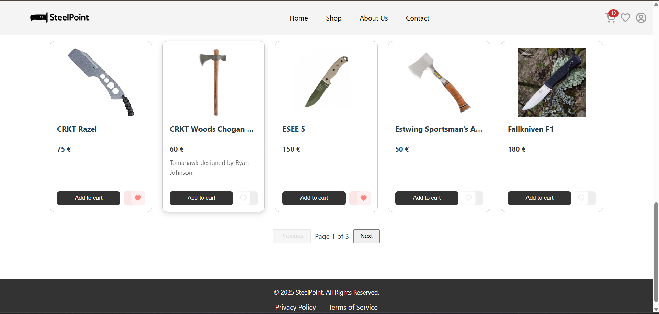

- Figure A.2 — Filtering and Sorting Dropdowns Above Product Grid
(Referenced in Introduction and Interface Description) 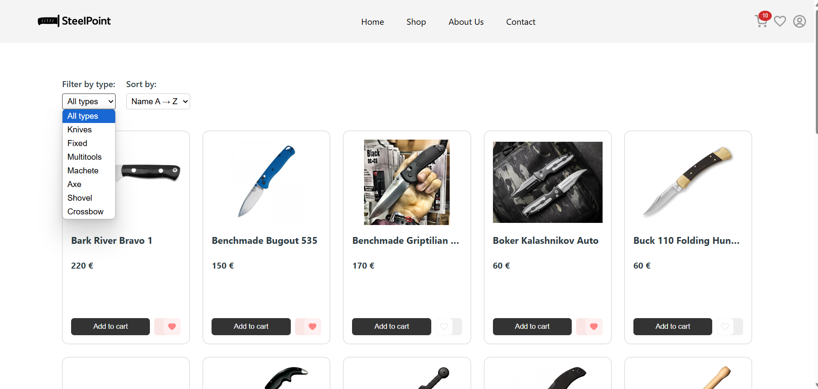

- Figure A.3 — Shopping Cart Drawer with Selected Items
(Referenced in Introduction and Interface Description) 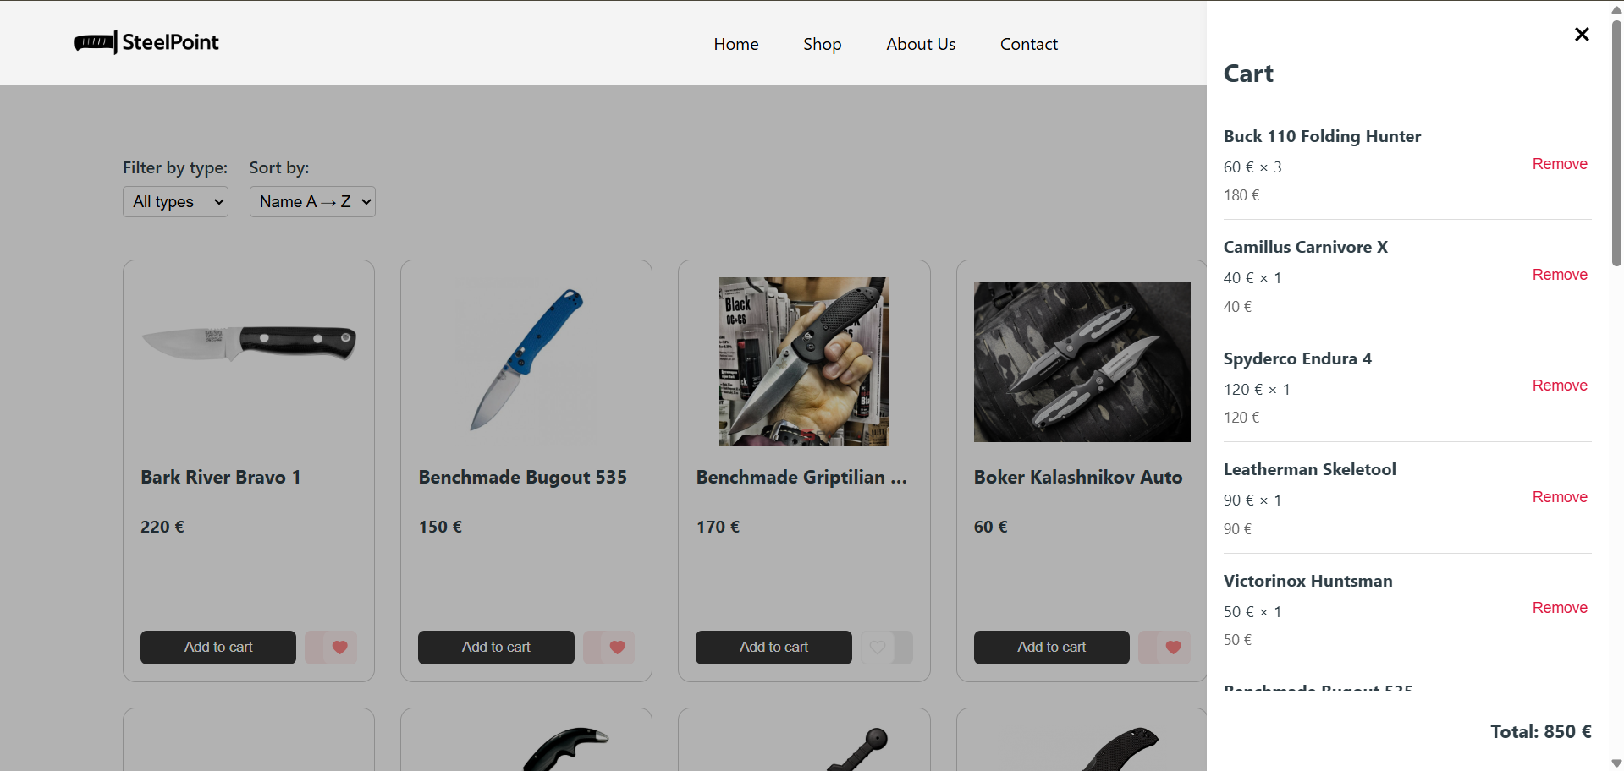

- Figure A.4 — Favorites Page Showing Selected Products
(Referenced in Interface Description) 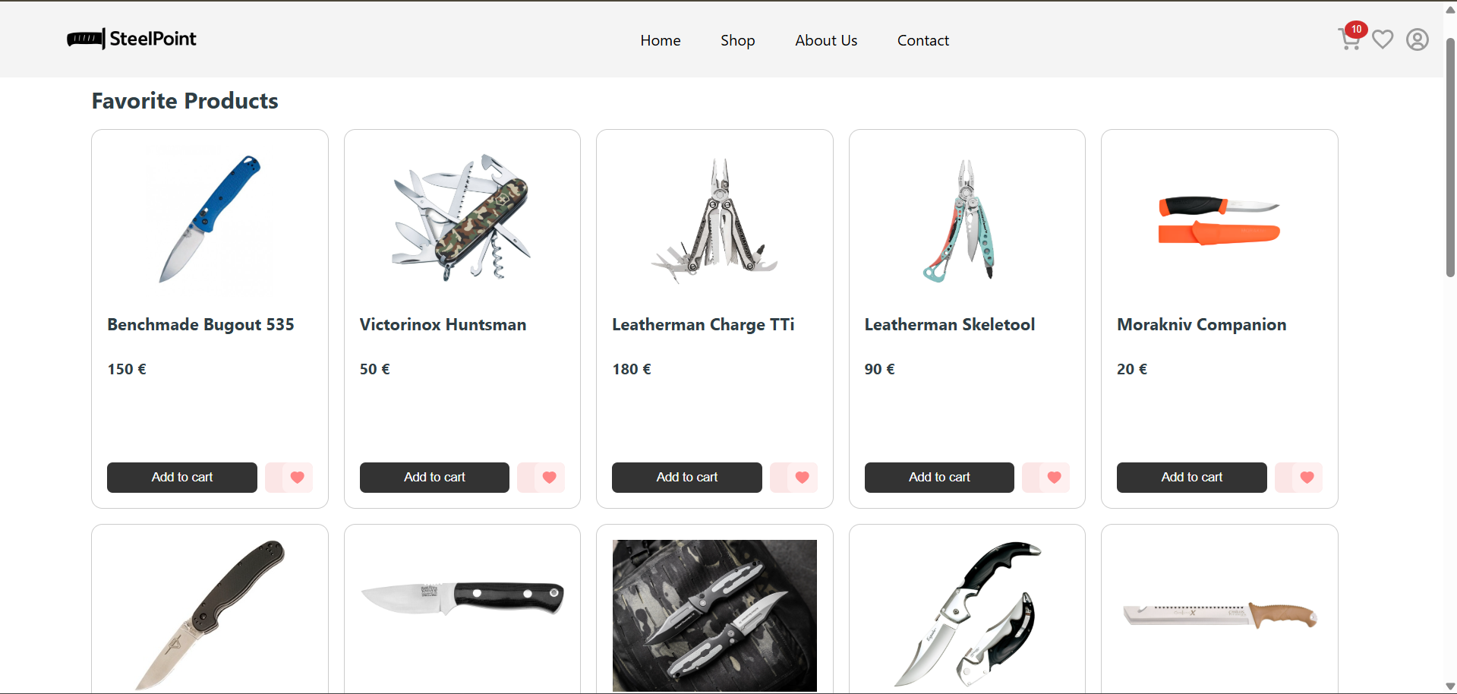

- Figure A.5 — Product Detail Placeholder Page with Skeleton Loader
(Referenced in Interface Description) 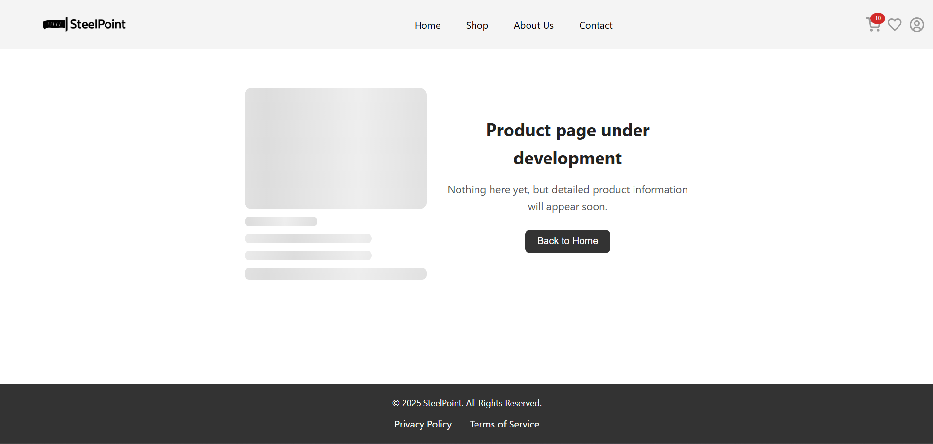

- Figure A.6 — Frontend Project Structure (IDE Screenshot)
(Referenced in Architecture section)
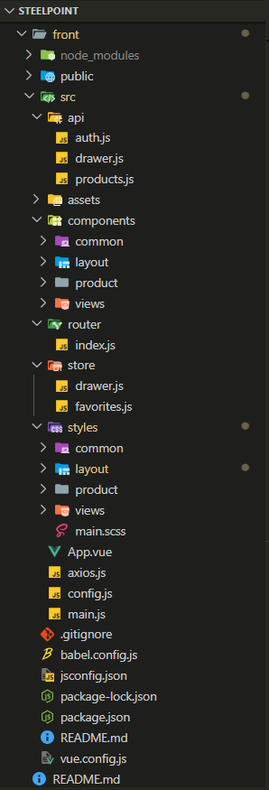
- Figure A.7 — Backend Project Structure (IDE Screenshot)
(Referenced in Architecture section) 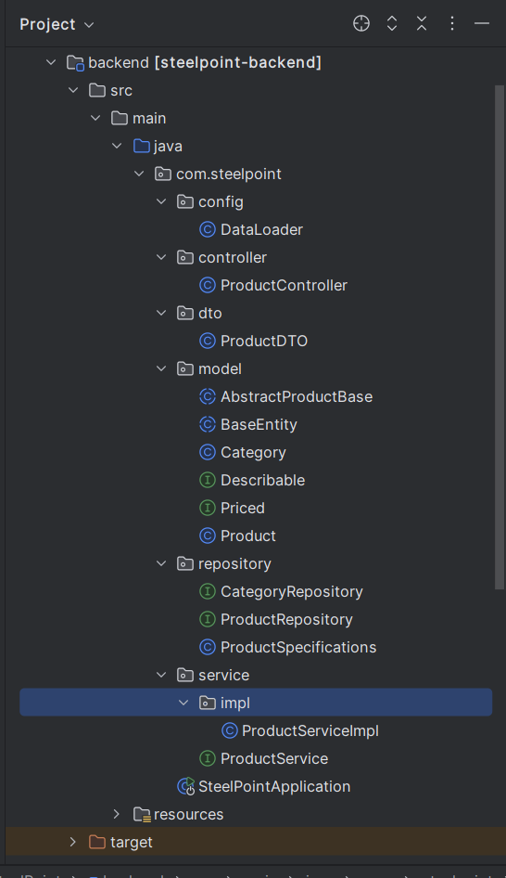

- Diagram A.8 — Overall System Architecture: Frontend ↔ Backend ↔ Database
(Referenced in Architecture section) 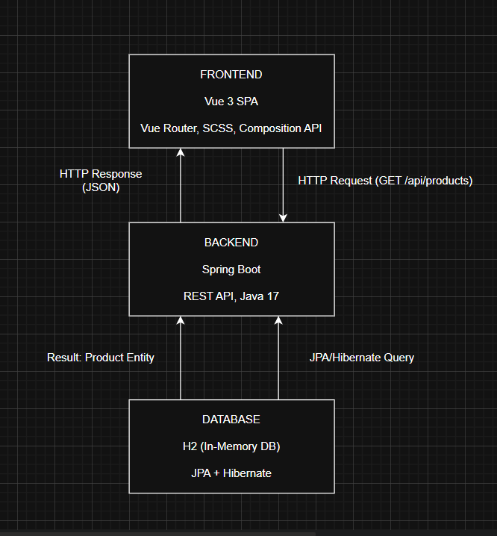

B – Block Diagrams of Application Logic
- Diagram B.1 — Add to Cart Logic
(Referenced in Algorithms and Logic section) 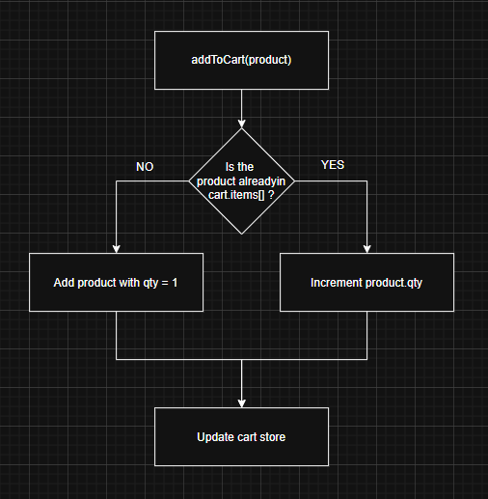

- Diagram B.2 — Toggle Favorite Logic
(Referenced in Algorithms and Logic section) 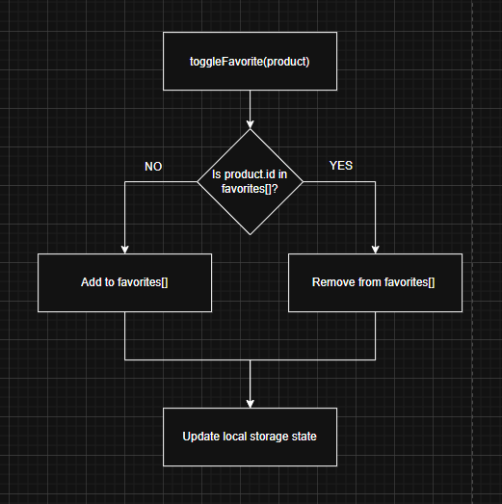

- Diagram B.3 — applyFilters() Logic (Client-side Filtering & Sorting)
(Referenced in Algorithms and Logic section) 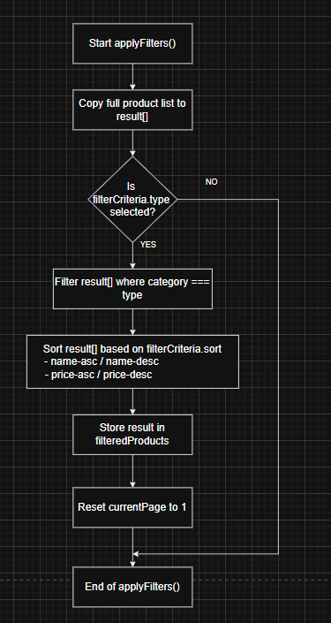

- Diagram B.4 — Backend Filtering Logic from filterProducts()
(Referenced optionally in Algorithms and Logic section) 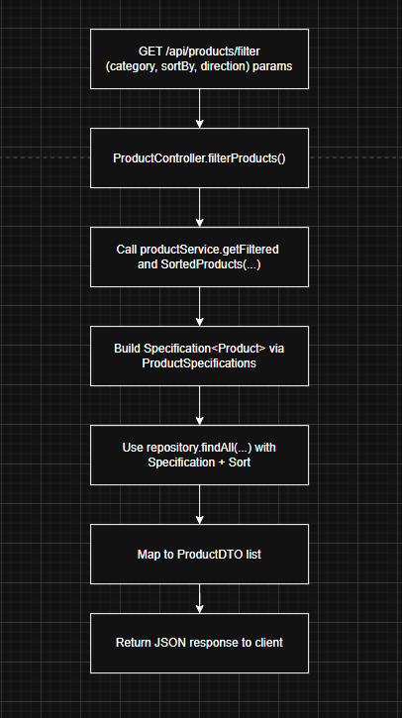

C – UML Class Diagram
- Diagram C.1 — UML Diagram Showing Relationships Among BaseEntity, AbstractProductBase, Product, Category, and Interfaces
  - BaseEntity → AbstractProductBase → Product
  - Product ↔ Priced, Describable
  - Category 1:N Product
(Referenced in Class Structure section) 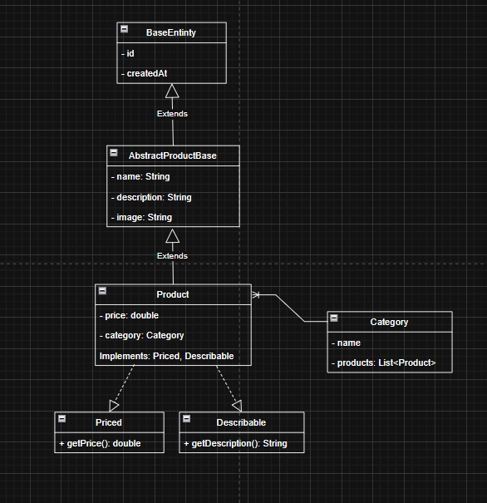

D – Java Backend Code Snippets
D.1 – Data Initialization
- DataLoader.java:
  - run(...) method
  - new Product(...) creation
  - saveAll(...) call
(Referenced in Problem Statement section)

@Override
public void run(String... args) {
if (productRepository.count() > 0) {
System.out.println("The database already contains products, autoloading is not required.");
return;
}
// Create categories
Category knives = new Category();
knives.setName("Knives");
Category multitools = new Category();
multitools.setName("Multitools");
Category fixed = new Category();
fixed.setName("Fixed");
categoryRepository.saveAll(List.of(knives, multitools, fixed));
// Create products and assign categories
productRepository.saveAll(List.of(
new Product("Spyderco Endura 4", "Folding knife with VG-10 blade.", 120.0, "/images/endura4.jpg", knives),
new Product("Victorinox Huntsman", "Compact Swiss knife with 15 tools.", 50.0, "/images/huntsman.jpg", multitools),
new Product("Morakniv Companion", "Light bushcraft knife with rubber grip.", 20.0, "/images/companion.jpg", fixed),
));
System.out.println("Demo products and categories added successfully.");
}

D.2 – Controller Layer
- ProductController.java:
  - @GetMapping("/api/products")
  - @GetMapping("/filter") method
(Referenced in Problem Statement and Architecture sections)

@RestController
@RequestMapping("/api/products")
@CrossOrigin(origins = "*")
public class ProductController {
private final ProductService productService;
public ProductController(ProductService productService) {
this.productService = productService;
}
@GetMapping
public List<ProductDTO> getAll() {
return productService.getAllProducts();
}
@GetMapping("/filter")
public List<ProductDTO> filterProducts(
@RequestParam(required = false) String category,
@RequestParam(required = false, defaultValue = "name") String sortBy,
@RequestParam(required = false, defaultValue = "asc") String direction
) {
return productService.getFilteredAndSortedProducts(category, sortBy, direction);
}
}

D.3 – DTO Layer
- ProductDTO.java:
  - Constructor
  - Getters for name, category, etc.
(Referenced in Architecture section)

public class ProductDTO {
private Long id;
private String name;
private String description;
private double price;
private String image;
private String category;
public ProductDTO(Product product) {
this.id = product.getId();
this.name = product.getName();
this.description = product.getDescription();
this.price = product.getPrice();
this.image = product.getImage();
this.category = product.getCategory() != null
? product.getCategory().getName()
: null;
}
public String getName() { return name; }
public String getCategory() { return category; }
}

D.4 – Model Layer
- BaseEntity.java:
  - Fields: id, createdAt

@MappedSuperclass
@Getter
@Setter
public abstract class BaseEntity {
@Id
@GeneratedValue(strategy = GenerationType.IDENTITY)
private Long id;
private LocalDateTime createdAt = LocalDateTime.now();
}

- AbstractProductBase.java:
  - Fields: name, description, image

@MappedSuperclass
@Getter
@Setter
public abstract class AbstractProductBase extends BaseEntity {
@NotBlank
protected String name;
protected String image;
protected String description;
}

- Product.java:
  - Class header, interface implementation, annotations

@Entity
@Getter
@Setter
public class Product extends AbstractProductBase implements Priced, Describable {
@Positive
private double price;
@ManyToOne
private Category category;
@Override
public double getPrice() { return price; }
@Override
public String getDescription() { return description; }
}

- Priced.java / Describable.java:
  - Interface signatures

public interface Priced {
double getPrice();
}
public interface Describable {
String getDescription();
}

- Category.java:
  - @OneToMany(mappedBy = "category"), field List<Product>
(Referenced in Class Structure section)

@Entity
@Getter
@Setter
public class Category extends BaseEntity {
private String name;
@OneToMany(mappedBy = "category")
private List<Product> products;
}

D.5 – Repository Layer
- ProductRepository.java, CategoryRepository.java:
  - Interface headers

public interface ProductRepository
extends JpaRepository<Product, Long>,
JpaSpecificationExecutor<Product> {
}
public interface CategoryRepository extends JpaRepository<Category, Long> { }

- ProductSpecifications.java:
  - hasCategory(...) method
(Referenced in Architecture section if included)

public static Specification<Product> hasCategory(String categoryName) {
return (root, query, cb) ->
categoryName == null ? null :
cb.equal(cb.lower(root.get("category").get("name")), categoryName.toLowerCase());
}

D.6 – Service Layer
- ProductService.java:
  - Method signatures: getAllProducts(), getFilteredAndSortedProducts(...)

public interface ProductService {
List<ProductDTO> getAllProducts();
Product getProductById(Long id);
Product saveProduct(Product product);
void deleteProduct(Long id);
List<ProductDTO> getProducts(String category, String sortBy);
List<ProductDTO> getFilteredAndSortedProducts(String category, String sortBy, String direction);
}

- ProductServiceImpl.java:
  - Full implementation of getFilteredAndSortedProducts(...)
(Referenced in Architecture section)

@Service
public class ProductServiceImpl implements ProductService {
private final ProductRepository productRepository;
public ProductServiceImpl(ProductRepository productRepository) {
this.productRepository = productRepository;
}
@Override
public List<ProductDTO> getAllProducts() {
return productRepository.findAll()
.stream()
.map(ProductDTO::new)
.collect(Collectors.toList());
}
@Override
public Product getProductById(Long id) {
return productRepository.findById(id).orElse(null);
}
@Override
public Product saveProduct(Product product) {
return productRepository.save(product);
}
@Override
public void deleteProduct(Long id) {
productRepository.deleteById(id);
}
@Override
public List<ProductDTO> getProducts(String category, String sortBy) {
Specification<Product> spec = Specification.where(null);
if (category != null && !category.isEmpty()) {
spec = spec.and(ProductSpecifications.hasCategory(category));
}
Sort sort = getSort(sortBy, "asc");
return productRepository.findAll(spec, sort)
.stream()
.map(ProductDTO::new)
.collect(Collectors.toList());
}
@Override
public List<ProductDTO> getFilteredAndSortedProducts(String category, String sortBy, String direction) {
Specification<Product> spec = Specification.where(null);
if (category != null && !category.isEmpty()) {
spec = spec.and(ProductSpecifications.hasCategory(category));
}
Sort sort = getSort(sortBy, direction);
return productRepository.findAll(spec, sort)
.stream()
.map(ProductDTO::new)
.collect(Collectors.toList());
}
private Sort getSort(String sortBy, String direction) {
Sort.Direction dir = "desc".equalsIgnoreCase(direction) ? Sort.Direction.DESC : Sort.Direction.ASC;
return switch (sortBy) {
case "price" -> Sort.by(dir, "price");
case "name" -> Sort.by(dir, "name");
default -> Sort.unsorted();
};
}
}

D.7 – Main Application
- SteelPointApplication.java:
  - @SpringBootApplication
  - main() method
(Referenced in Setup section)

@SpringBootApplication
public class SteelPointApplication {
public static void main(String[] args) {
SpringApplication.run(SteelPointApplication.class, args);
}
}
K,,,,,,,,,,,,,,,,,,,,,,,,,,,,,,,,,,,,,,,,,,,,,,,,,,,,,,,,,,, møöpppppppæ€

D.8 – Frontend Routing
- router/index
  - Route setup (e.g., /, /product/:id, /favorites)
(Referenced in Architecture section)

const routes = [
{ path: '/', name: 'Home', component: HomeView },
{ path: '/favorites', name: 'Favorites', component: FavoritesView },
{ path: '/product/:id', name: 'ProductDetail', component: () => import('@/components/views/ProductDetail.vue') }
]

D.9 – Filtering Logic
- ProductList.vue:
  - applyFilters() function
(Referenced in Interface and Logic section)

// Apply filtering and sorting
function applyFilters() {
let result = [...products.value]

// Filter by type
if (filterCriteria.value.type) {
const selectedType = filterCriteria.value.type.toLowerCase()
result = result.filter(p => {
let category = typeof p.category === 'string' ? p.category : p.category?.name
return category?.toLowerCase() === selectedType
})
}

// Sort based on selected criteria
switch (filterCriteria.value.sort) {
case 'name-asc':
result.sort((a, b) => a.name.localeCompare(b.name))
break
case 'name-desc':
result.sort((a, b) => b.name.localeCompare(a.name))
break
case 'price-asc':
result.sort((a, b) => a.price - b.price)
break
case 'price-desc':
result.sort((a, b) => b.price - a.price)
break
}

filteredProducts.value = result
}

